**WILSON SPORTING GOODS**

*Developer Guide*

|  |  |  |
| --- | --- | --- |
| **Supervisor.** | **Miss Muniba** | |
| **Batch.** | **2110F1** | |
| **Group.** | B | |
| **Serial No.** | **Enrollment Number** | **Student Name** |
| 1. | 1340171 | ZUBAIR UDDIN |
| 2. | 1340130 | MUHAMMAD AALYAN JAVED |
| 3. | 1340168 | MUHAMMAD ZAID AHMED |
| 4. | 1340182 | USMAN NASIR |

1. **Home** (*index(NEW).html*)

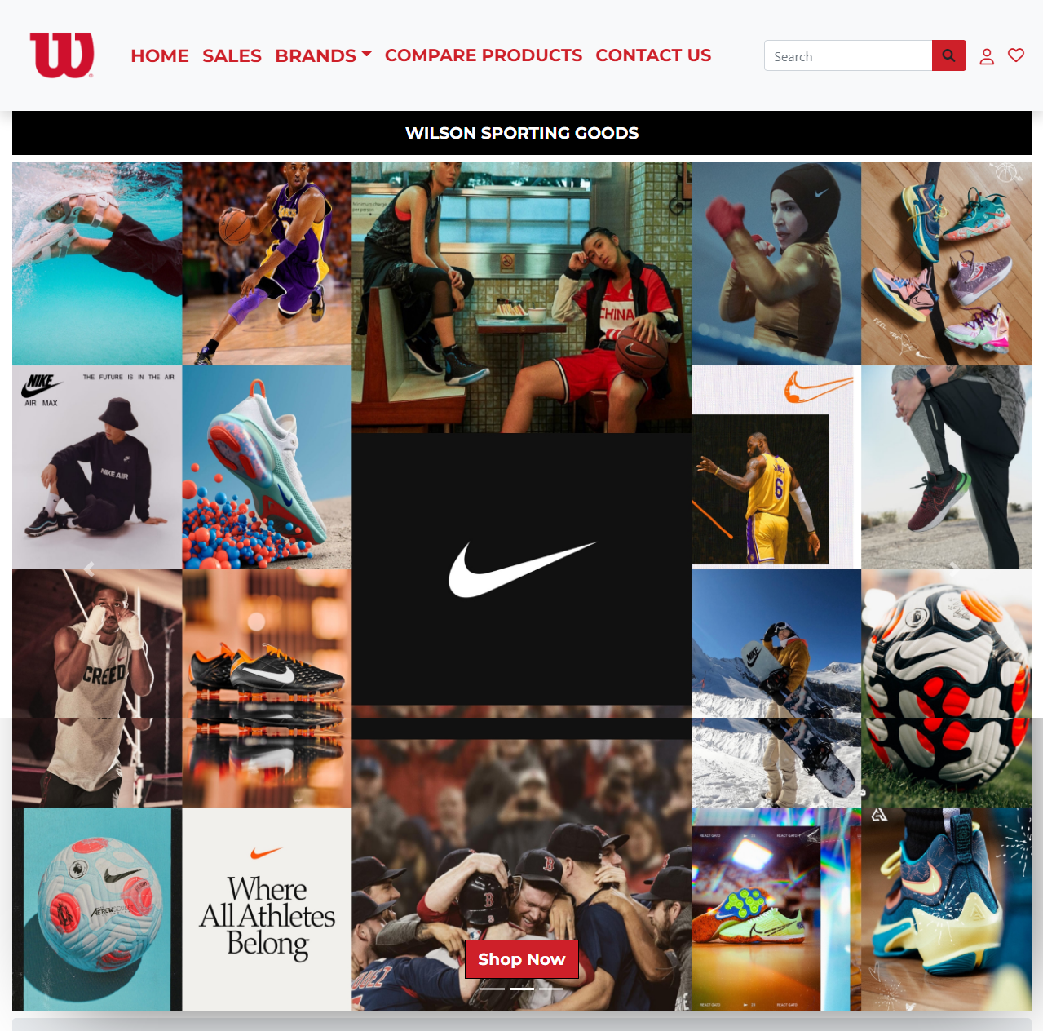

***Figure 1: Home page to Nexus aquarium***

 Our Slogan has given to the peoples toward our website. “**WILSON SPORTING GOODS** ”.

* By clicking (**SHOP NOW**) button user while redirect to the main webpage.

**Code of Home page**

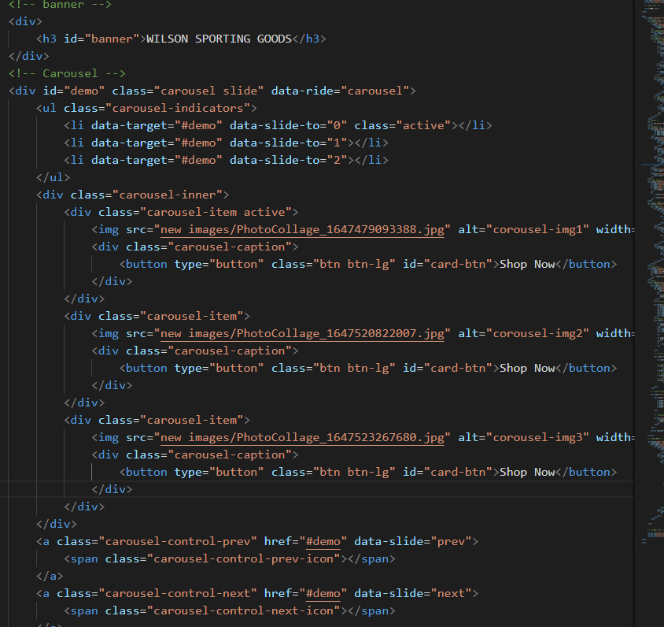

1. **Navbar (index (1).html)**

HOME **SALES**  BRANDS COMPARE_PRODUCTS CONTACT US

***Figure 2: Navbar***

We have given five essentials. By clicking any of the essential’s and redirect to the linked page. (0. index (1).html)

**Code of Navbar**

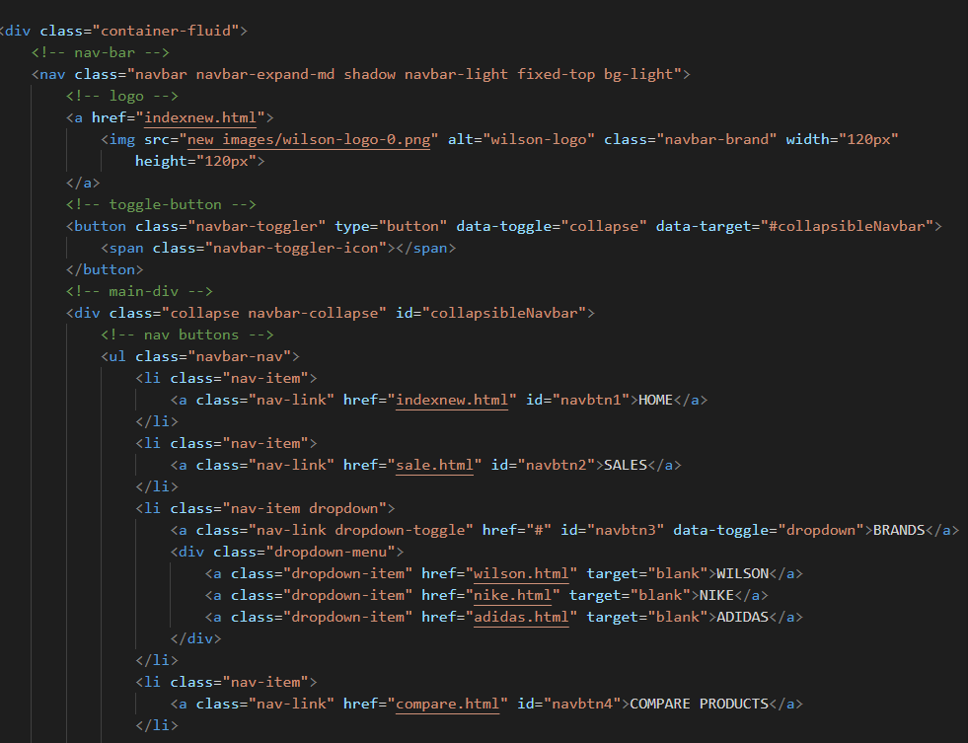

1. **Sales (sale.html)**



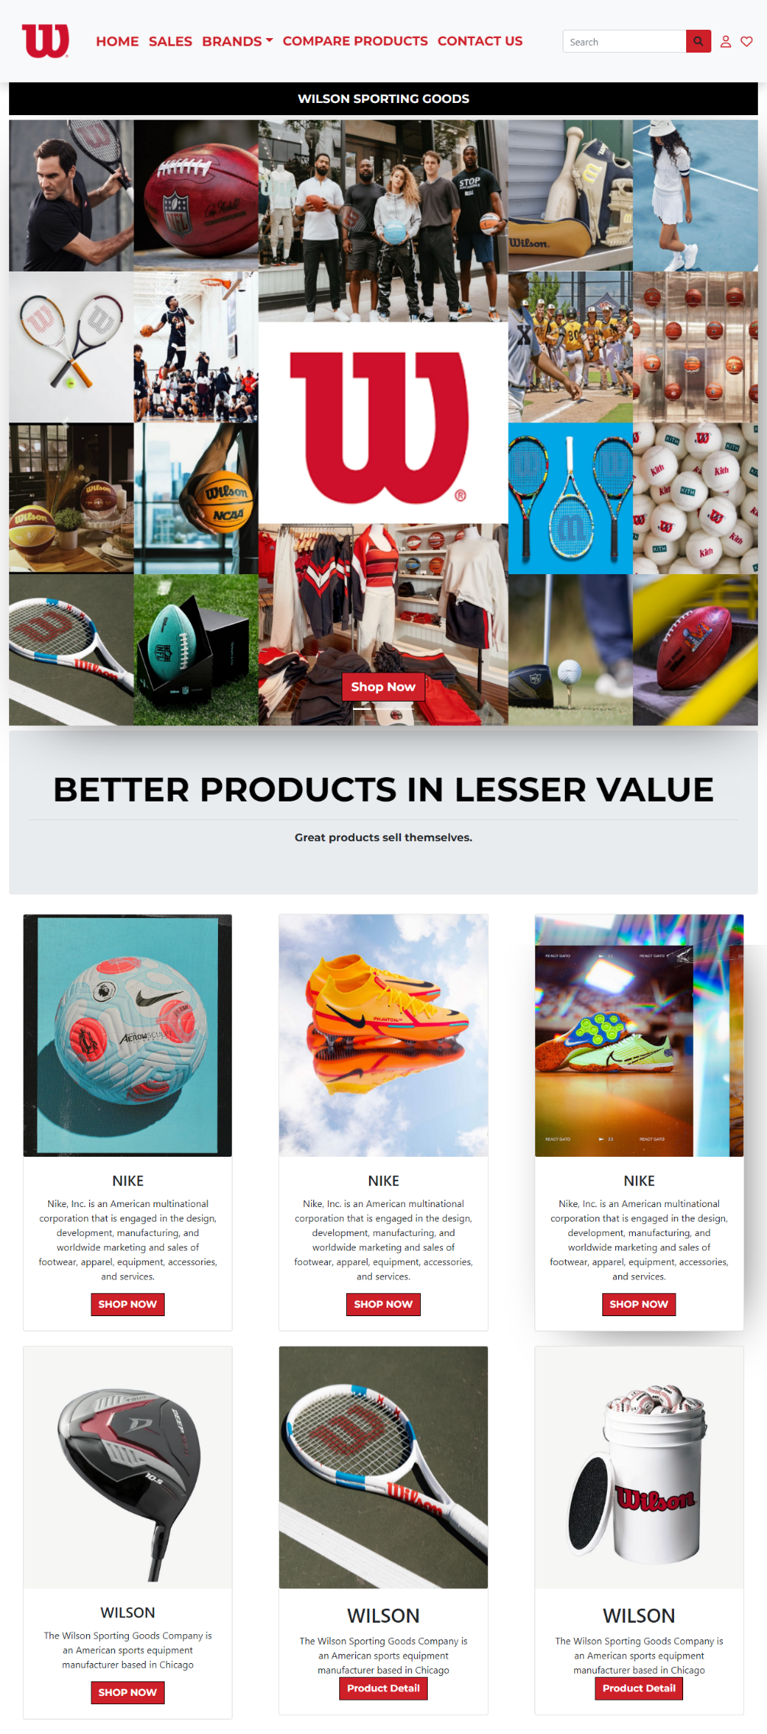

 ***Figure 3: Sales***

**

* Buy Our Unique Products.*

* Discover all about our weird and wonderful Offers with fun and interactive learning experience.*

* *To be a destination of choice where all are welcome and motivated to join as a driving force for Fashion able life.*
* ***Code of About Us***

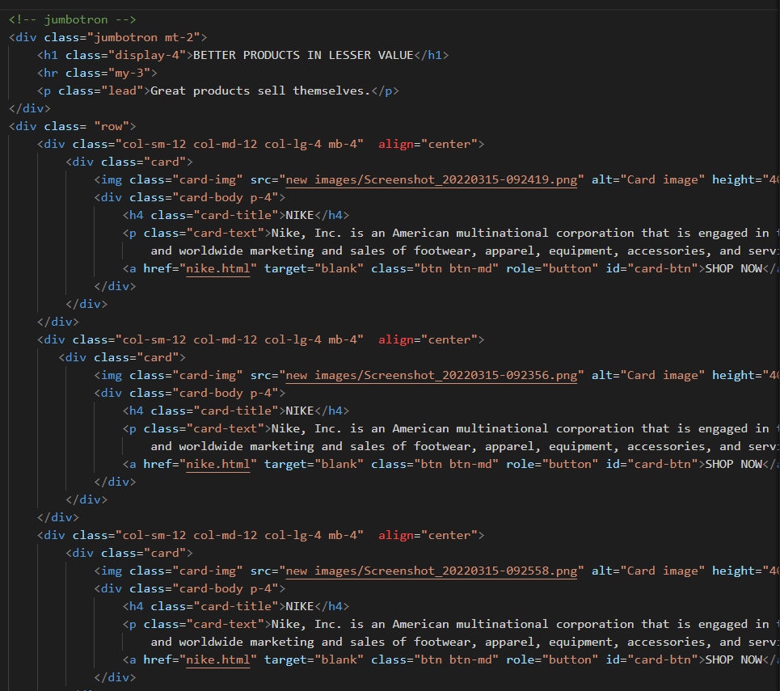

*We have mentioned our basic services to make people known about the brands we provide.*

**Brands (indexnew.html)**

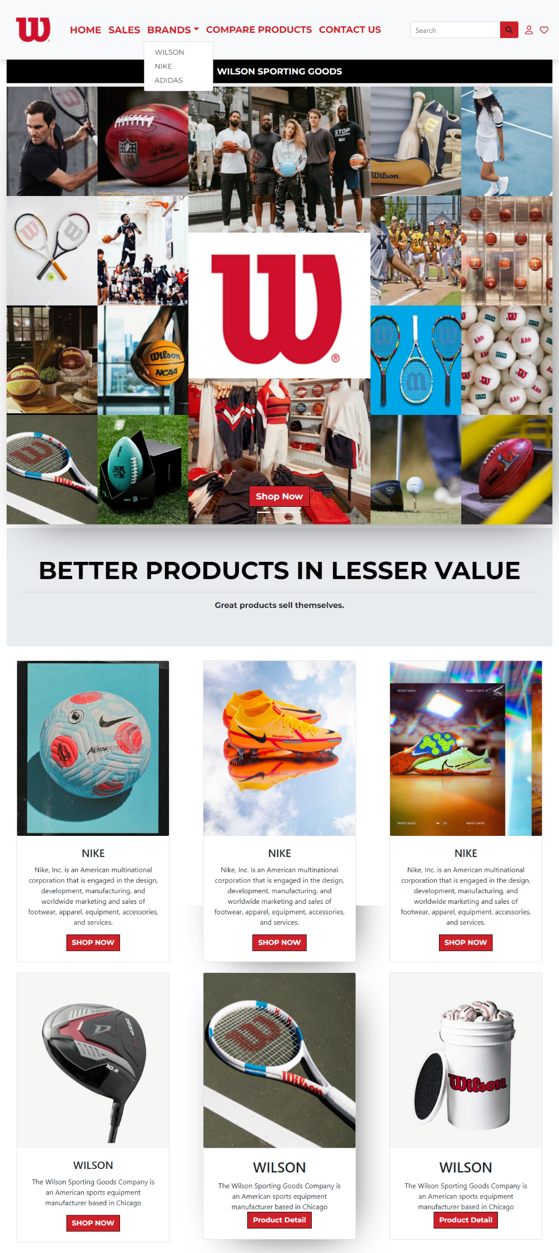

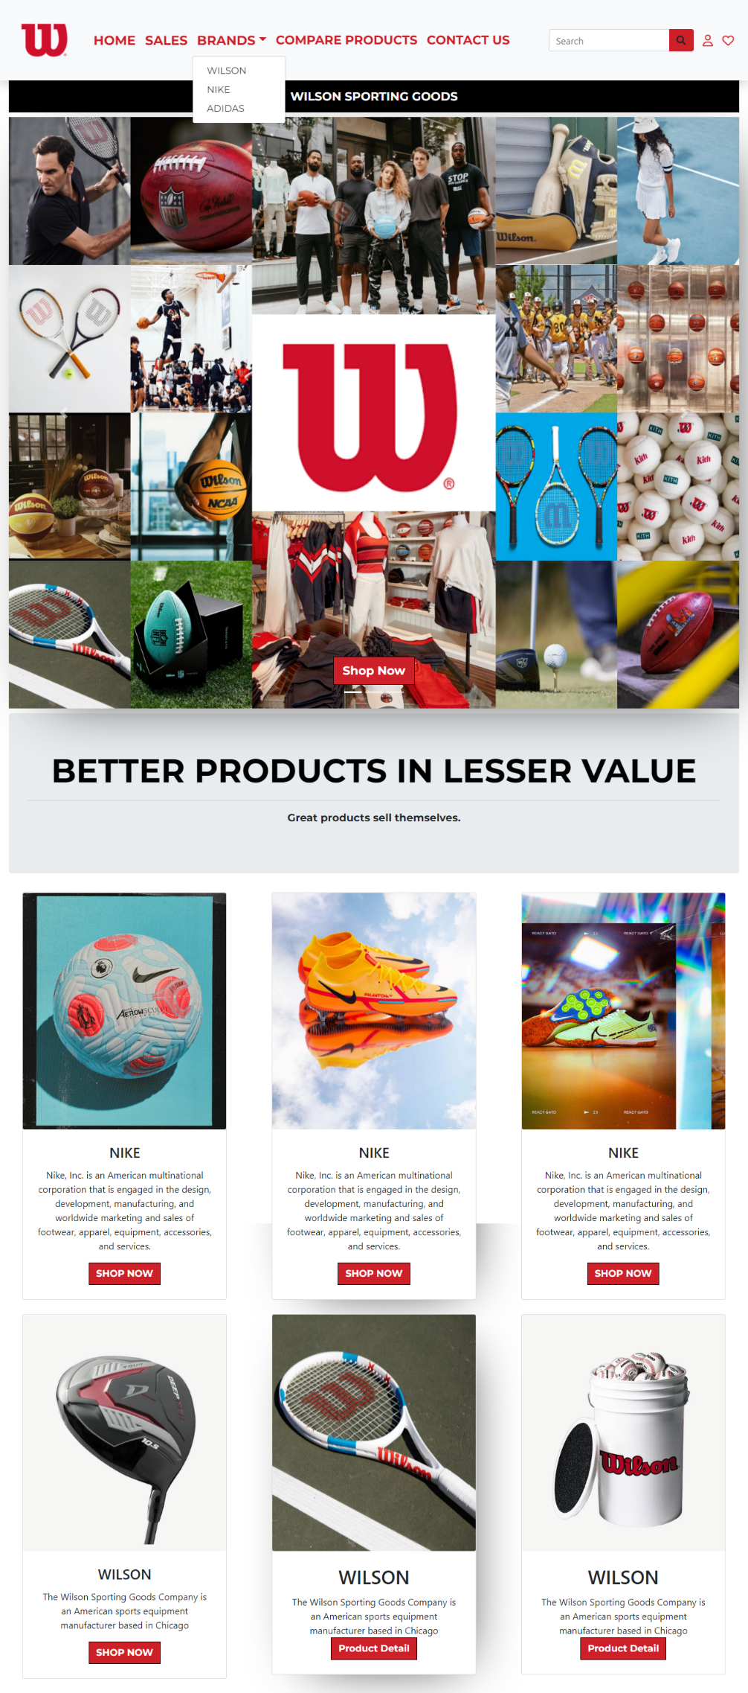

***Figure 4: Service***

** ***Home based casual or formal dresses:*** *On our first service we have mentioned about providing home-based brands and providing them.*

***About Brands:*** *We have mentioned that we are providing international and well stuff brands to the customer.*

***Customer Service:*** *For the ease of the people our website us providing customer service for the customer so that they can contact directly to our site members/workers*

1. ***COMPARE-PRODUCT(compare.html)***

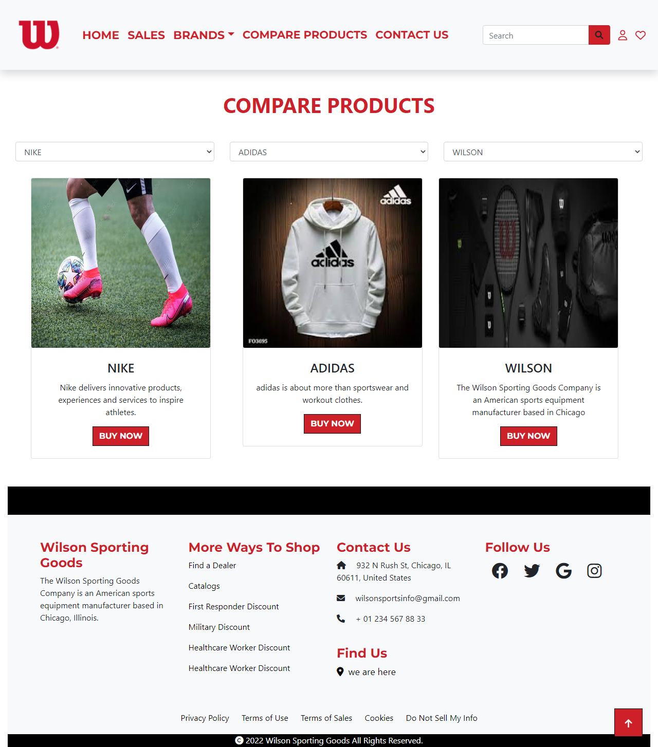

1. ***Nav bar:***

HOME **SALES**  BRANDS COMPARE_PRODUCTS CONTACT US

***Figure 6: Description of our Nav bar***

***Use to load the remaining sections. The following is a list of those sections:***

*As we have work on only single page and re-directing on other sections. So we are made our web directed pages.*

* ***Home Page (1. indexnew.html)***
* ***About Page (2. about.html- About Section)***
* ***Brands Page (3.indexnew.html-)***
* ***Contact Page (5. contact.html)***
* ***Compare-product (4. compare.html )***

***Figure 9: Our Team***

***Code of Our Team***

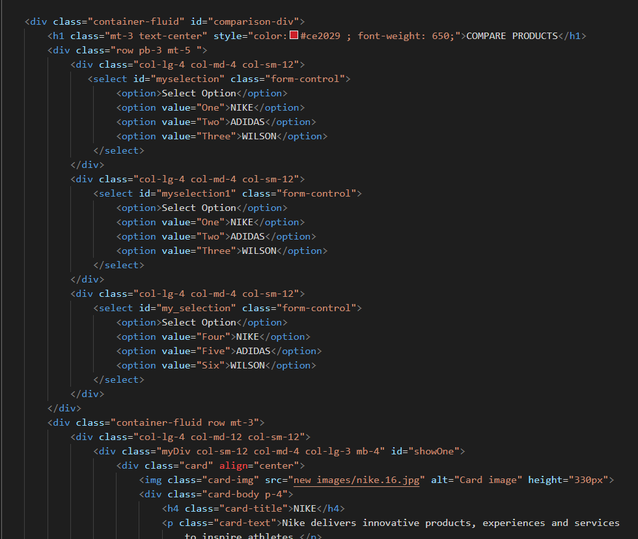

***7 Contact us :***

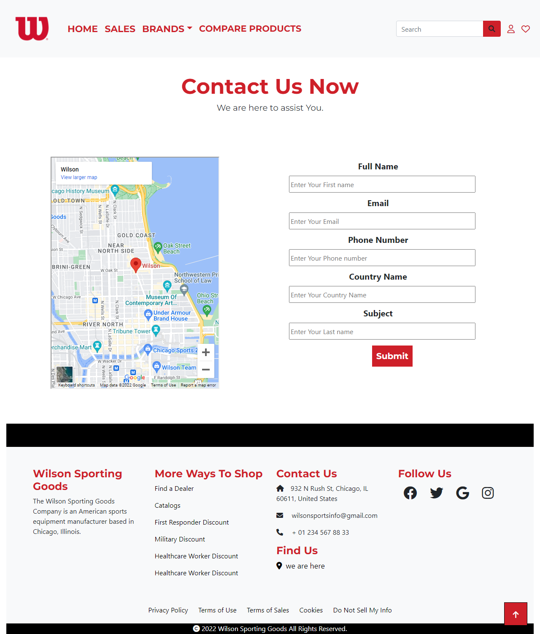

***Figure 13: Contact***

*In our contact section we have given location map for the ease of the people*

*Email id and phone number for contacting in case of any problem.*

*Feedback Form:*

*To know the response of the people our team has given feedback page for the ideas and feedback of the people.*

***Figure 14: Footer***

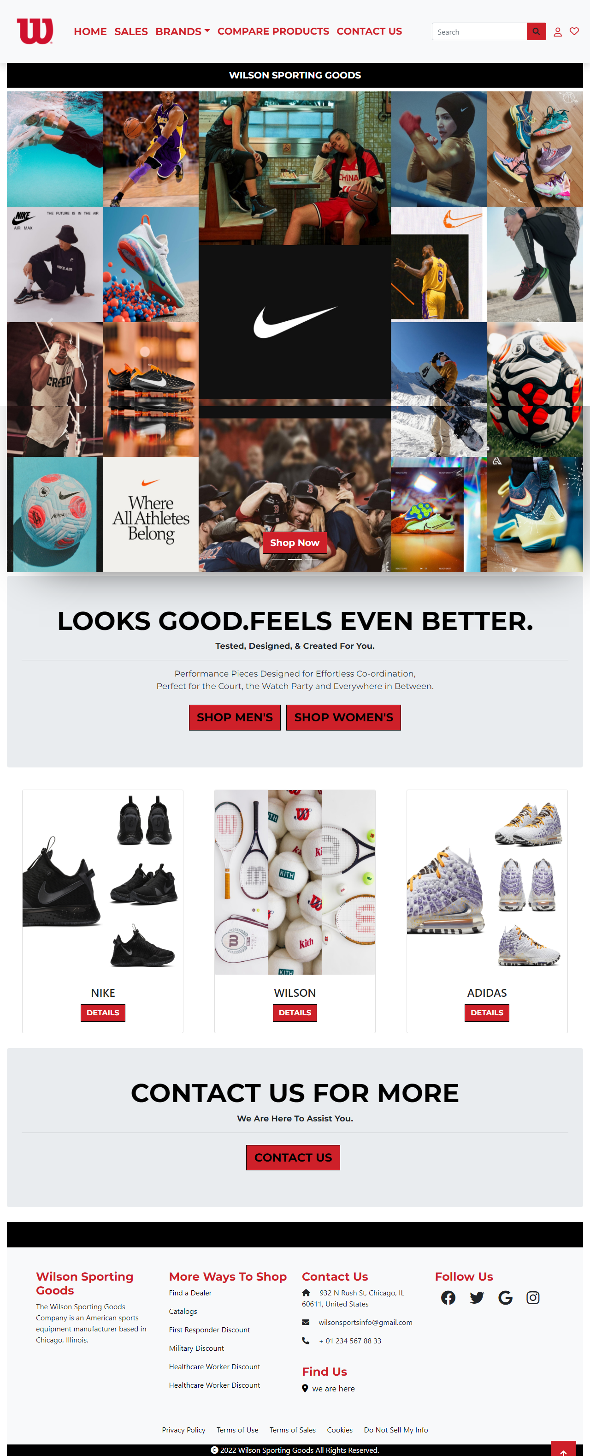

We have given some simple things in footer to make our website more relaxing. Copyrights are given in the end of the website and effects of Facebook Instagram and twitter are also mentioned for making the website attractive